|  |  |  |  |
| --- | --- | --- | --- |
| 1 | | 15,000 | |
| **NUMERO DE FRONTERAS** | | **ENERGIA AGREGADA** | |
|  | | | |
| 36,693,296 | 85 | | 1,342,191 |
| INGRESO 2019 | DÍAS CERTIFICADOS 2019 | | ENERGIA RESPALDADA 2019 |
|  | | | |
| 54,621,628 | 155 | | 1,974,224 |
| INGRESO 2020 | DÍAS CERTIFICADOS 2020 | | ENERGIA RESPALDADA 2020 |
|  | | | |
| 14,303,547 | 43 | | 644,933 |
| INGRESO 2021 | DÍAS CERTIFICADOS 2021 | | ENERGIA RESPALDADA 2021 |

**HISTORICO REINTEGRO DDV**

|  |  |  |  |
| --- | --- | --- | --- |
|  | **2019** | **2020** | **2021** |
| **ENE** | - | 9.58 | - |
| **FEB** | - | 13.1 | - |
| **MAR** | - | 15.54 | - |
| **ABR** | - | - | - |
| **MAY** | - | 3.69 | - |
| **JUN** | - | 5.61 | - |
| **JUL** | - | 3.23 | - |
| **AGO** | 3.9 | 3.39 | 2.88 |
| **SEP** | 9.67 | - | 6.25 |
| **OCT** | 12.95 | 0.5 | 5.17 |
| **NOV** | 10.18 | - | - |
| **DIC** | - | - | - |

**Los valores de la tabla están en millones de COP**

**REINTEGRO MECANISMO DDV OCTUBRE 2021**

|  |  |  |  |  |  |
| --- | --- | --- | --- | --- | --- |
| FECHA | TIPO DIA | CANTIDADES RESPALDO | PRECIO PONDERADO USD | TRM | PNETO |
| 2021-10-01 | Viernes | 14,999 | 5.98 | 3,784.44 | 304,140 |
| 2021-10-02 | Sábado | 14,999 | 5.98 | 3,784.44 | 304,140 |
| 2021-10-03 | Domingo - Festivo | 14,999 | 5.98 | 3,784.44 | 304,140 |
| 2021-10-04 | Lunes | 14,999 | 5.98 | 3,784.44 | 304,140 |
| 2021-10-05 | Martes | 14,999 | 5.98 | 3,784.44 | 304,140 |
| 2021-10-06 | Miércoles | 14,999 | 5.98 | 3,784.44 | 304,140 |
| 2021-10-07 | Jueves | 14,999 | 5.98 | 3,784.44 | 304,140 |
| 2021-10-08 | Viernes | 14,999 | 5.98 | 3,784.44 | 304,140 |
| 2021-10-09 | Sábado | 14,999 | 5.98 | 3,784.44 | 304,140 |
| 2021-10-10 | Domingo - Festivo | 14,999 | 5.98 | 3,784.44 | 304,140 |
| 2021-10-11 | Lunes | 14,999 | 5.98 | 3,784.44 | 304,140 |
| 2021-10-12 | Martes | 14,999 | 5.98 | 3,784.44 | 304,140 |
| 2021-10-13 | Miércoles | 14,999 | 5.98 | 3,784.44 | 304,140 |
| 2021-10-14 | Jueves | 14,999 | 5.98 | 3,784.44 | 304,140 |
| 2021-10-19 | Martes | 14,999 | 5.98 | 3,784.44 | 304,140 |
| 2021-10-20 | Miércoles | 14,999 | 5.98 | 3,784.44 | 304,140 |
| 2021-10-21 | Jueves | 14,999 | 5.98 | 3,784.44 | 304,140 |

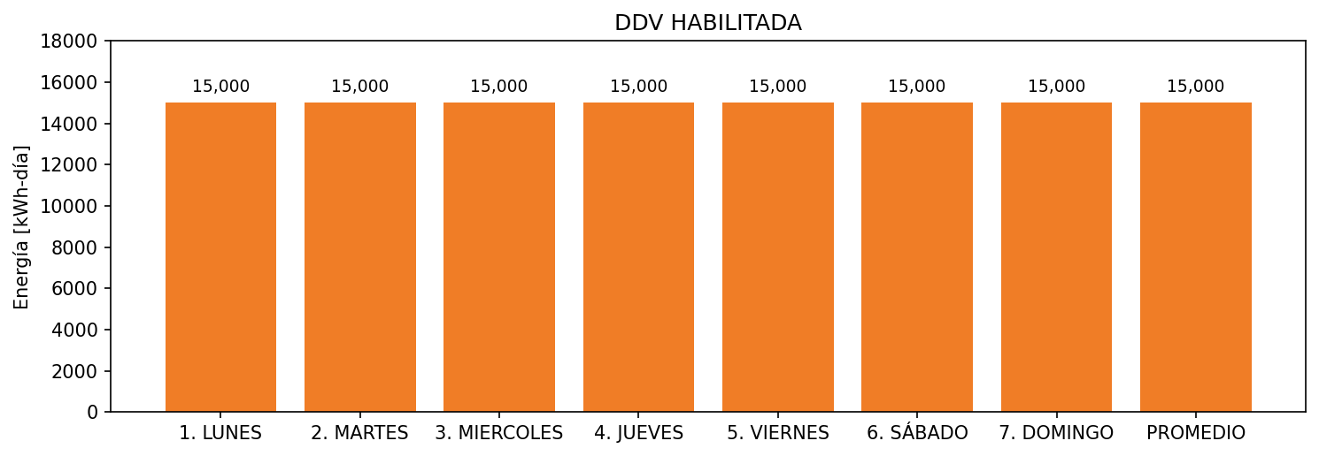

|  |  |  |  |  |  |  |  |  |  |
| --- | --- | --- | --- | --- | --- | --- | --- | --- | --- |
| **FRONTERA** | **COD SIC** | **FRT DDV** | **TIPO DDV** | **PROMEDIO** | **PRÓXIMA ACTUALIZACIÓN** | **MARGEN DE ERROR** | **ÚLTIMA PRUEBA DDV** | **DÍAS PARTICIPACIÓN** | **FECHA REFERENCIA PRÓXIMA PRUEBA DDV** |
| FIDEICOMISO HOTEL GRAND HYATT CEMSA | Frt32311 | Frt42313 | GPE | 15,000 | 2026-04-15 | NO APLICA | 2021-08-10 | 43.0 | 2022-01-28 |